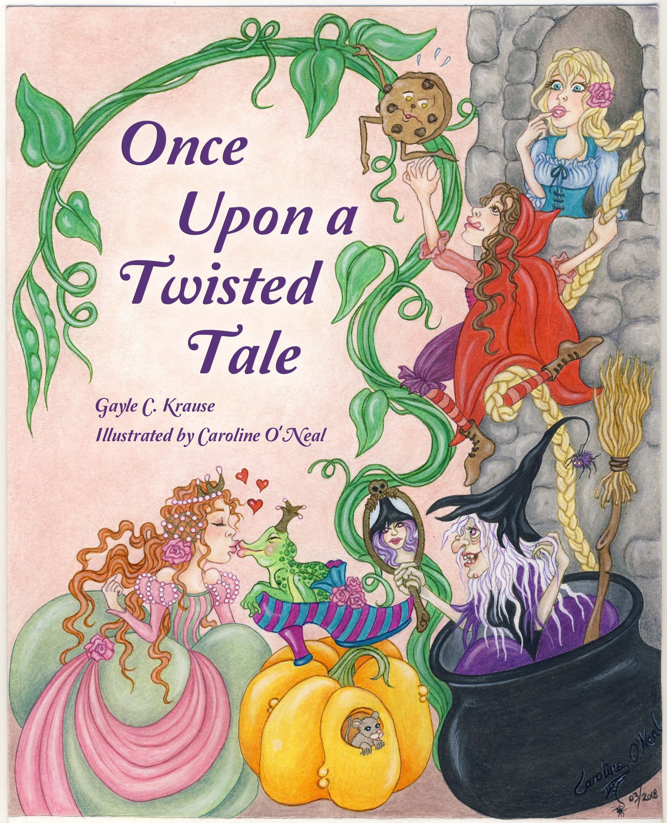

**ONCE UPON A TWISTED TALE**

**AUTHOR – GAYLE C. KRAUSE**

**ILLUSTRATOR – CAROLINE O’NEAL**

**TEACHERS’S GUIDE**

**GRADES 1-4**

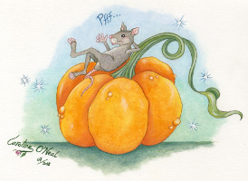

**GAYLE C. KRAUSE - AUTHOR**

Gayle C. Krause, M. Ed, has taught Children’s Literature, creative writing, and storytelling techniques to prospective teachers and children’s authors. Having loved fairy tales and rhymes as a child, she now combined both and twisted them together to make “fractured fairytales” in various poetry forms.

Ms. Krause writes Picture Books, Middle Grade, and Young Adult novels. Rebecca Angus of Golden Wheat Literary Agency represents her. You can find the latest news about her books at [www.gayleckrause.com](http://www.gayleckrause.com)

**CAROLINE O’NEAL – ILLUSTRATOR**

A self-taught painter and illustrator, Caroline has been fascinated since childhood by legends, mythology, fantasy characters, fairytales, flora and fauna. She illustrates fantasy, horror and science fiction books and magazines. Follow Caroline at her website: [www.carolineoneal.com](http://www.carolineoneal.com)

**HOW TO USE THIS GUIDE**

ONCE UPON A TWISTED TALE is intended for children between 1st and 4th grade, although can be easily read and discussed in Kindergarten or used for more in-depth study of poetic forms and fairytales in the upper grades.

This book provides a wide range of teaching possibilities from creative dramatics to language arts and poetry. This book is an excellent study for aspects of fairytales (compare and contrast original story to mashed-up fractured stores) poetry (discuss and teach various poetry forms used in this book), an opportunity to create original “fractured fairytale” poems and writing skills.

________________________________________________________________________

Guide Content @Copyright 2019 Gayle C. Krause. This guide is free of charge for educational use only and was developed by the author/master teacher in conjunction with SPORK/Clearfork Publishing. This guide may not be published, reproduced, or sold without the express written consent of Gayle C. Krause.

**Language Arts: Comprehension, Vocabulary, Reading**

Pre-Reading:

Before reading ***ONCE UPON A TWISTED TALE***, identify and discuss fairytale characters from the front and back covers,

Front Cover:

* Discuss that this book has both an author and illustrator.
* What does the author do?
* What does the illustrator do?
* Discuss the characters on the front cover. Name them.
* Describe how the characters are mixed together and identify their original stories.
* Have students try to predict from the cover what the poems might be about.
* Read the original fairytales aloud in class or have a class discussion on each before reading the poems in ***ONCE UPON A TWISTED TALE.***
* Have each student choose a poem.

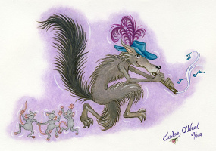

POST READING:

Comprehension Activities:

* Have students summarize their chosen poem in their own words.
* Consider what is known from the illustrations. Look at them separately from the words and tell the story from the picture. Now, listen to the words read aloud.
* Compare original fairytale to “twisted” fairytale.
* Determine the meaning of words and phrases as they are used in the poem.
* Determine the theme of the story in the poem.
* Identify poetry forms used in ***ONCE UPON A TWISTED TALE***

***ghazal, haiku, list, loop, cleave, couplet, pantoum, concrete, quatrain***

* Explain major differences between elements of poems. (verse, rhythm, meter)
* Compare and contrast the POV from which different story poems are narrated.

Writing Activities:

* (MAY BE DONE AS TEACHER-LED ACTIVITY) Write your own mixed up fairytale in prose or poetry form.

Poetry Activities:

* Find rhyming words in your selected poem and create your own list of rhyming words.
* Internal rhyme is often used in poetry. Find examples of internal rhyme (places within a line that rhyme, rather than at the end of the line)
* Repetition can be part of some poetry. How many times can you find repeated phrases?
* Alliteration is when the same letter is repeated at the beginning of words. Find examples of alliteration.

**ONCE UPON A TWISTED TALE**

**C I S J V N P R P N P E A O**

**P I P E R E A L O I U I R F**

**I K N M A H C E N T S N O W**

**N F Q D T K T A V Y S U H Y**

**O F C M E T H V F A I R Y M**

**C A U N F R O G C N N G Z K**

**C C H N N R E O B D B M P D**

**H N O O G A D L N I O T R Z**

**I X W Q E X P A L J O L I S**

**O U J U G Y Y I C A T J N K**

**N Q L E Z O R W O K S A C Q**

**W E M E R M A I D E Z H E N**

**T O N N L W K T F D E A S Z**

**K F L T N D M C A N D Y S A**

**D P J F Y G I H E Z D O L T**

Find these words: CANDY QUEEN FAIRY

SNOW PINOCCHIO WITCH WOLF

FROG MERMAID PUSS IN BOOTS CINDERELLA

PRINCESS PEA HEN PIPER

**DRAW YOUR FAVORITE FAIRYTALE CHARACTER HERE**